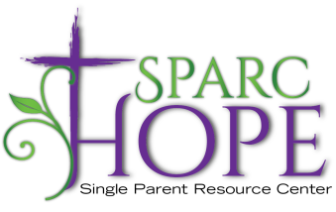

Job Description

**Position Title:** Development Coordinator **Time Commitment:** 35 hours per week

**Reports to:** Executive Director **Revised Date:** September 2024

**Description**

Through the development of strong relationships, the Development Coordinator will foster a culture of philanthropy and secure funds to support our mission and programs. This role will provide daily management to a growing and comprehensive development program, oversee all aspects of fund raising with a particular focus on annual giving, corporate/foundation relations and grants, donor prospect management, stewardship, and special events.

**Qualifications**

**Desired:**

* Bachelor’s Degree in communications, non-profit management, public relations or English
* Experience serving in a comprehensive fundraising role
* Record of success in cultivating, soliciting, and closing gifts
* Superior written/oral/interpersonal communication skills
* Precise attention to details
* Computer/technology literacy, MS Office, donor software and social media knowledge
* Experience in the grant writing process

**Competencies** *(Knowledge, Skills and Behaviors)*

* Interpersonal skills powered by a servant’s heart
* High degree of Emotional Intelligence
* Organizational and Time Management Skills
* Communication Skills with superior written/oral skills
* Creative, strategic thinking
* Technical Skills Computer/technology literacy, MS Office, donor software and social media knowledge
* Professionalism
* Negotiation Skills

**Job Responsibilities/Expectations**

* Increase current corporate and individual cash and in-kind donations
* Cultivate new donor relationships
* Build and maintain relationships with current donors and partners
* Oversee, manage and grow an annual fund- giving program of current donors and prospects comprised of individuals, corporations and foundations to secure annual operating support gifts
* Work closely with volunteer event committee to develop a strategy to ensure events are successful and impactful through targeted sponsorships for special events and ticket sales.
* Research, identify, write and submit successful grant applications to private and corporate foundation prospects. This process includes developing relationships with key program officers with our funding partners.
* Track and record daily activities, conversations and appointments in a donor relationship database.
* Provide weekly recaps with follow up and follow through next steps.
* Collaborate with the Development Committee Chairperson to ensure that financial goals are met.
* Increase community awareness by effectively representing Sparc Hope’s mission, vision, values and goals.